Task 7: Monitoring And Analyzing System Changes

Introduction
In this report, we will focus on analyzing and monitoring system changes using Windows Event Viewer and system logs and MITRE ATTA&CK frame work will be used to sort out potential threats. PowerShell script will be used to simulate files operation and security measures are outlined.
1. Download and Run the Enhanced PowerShell Script:
    - Create a folder and a file on your desktop.
Folder created
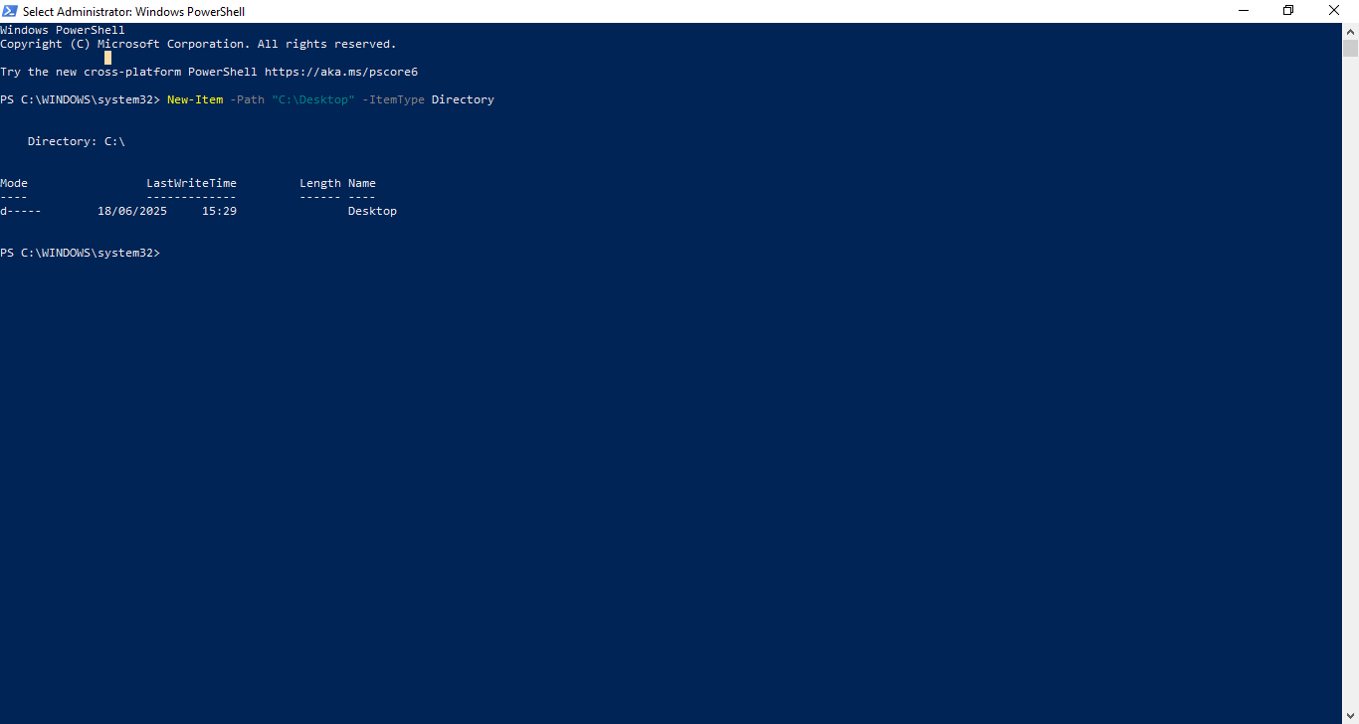
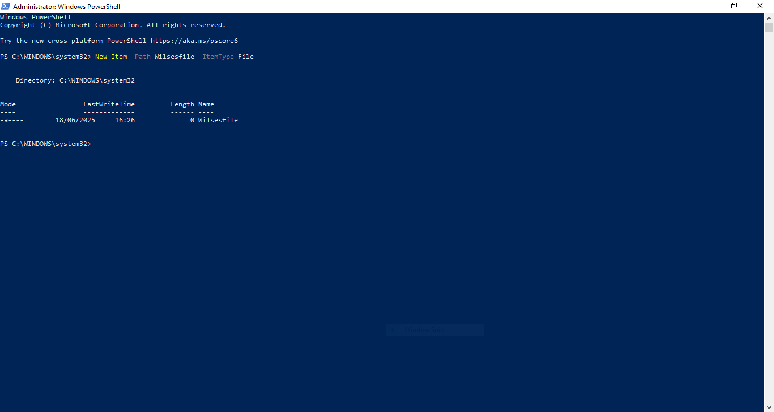
File created
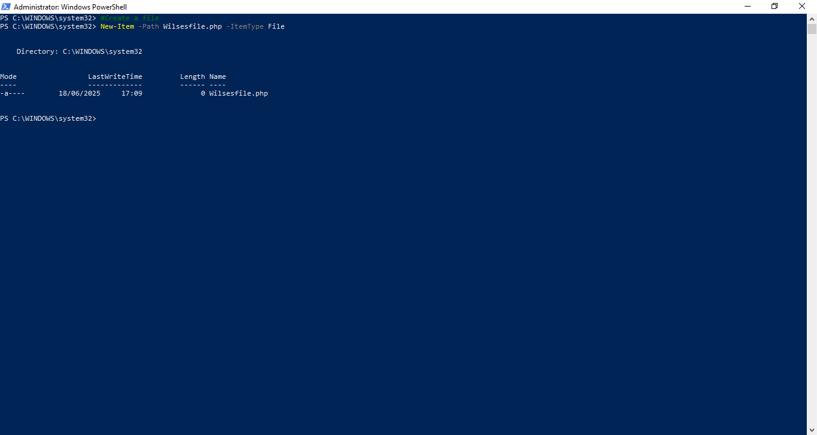
File created on Desktop
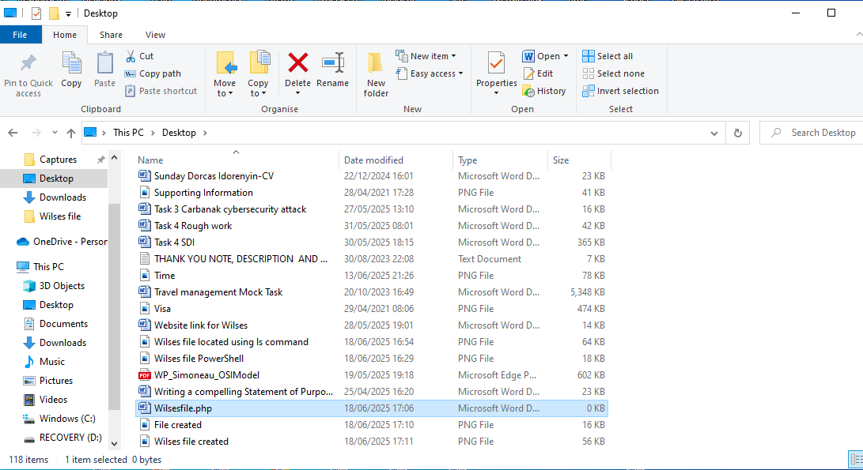
Wilses file content

    - Modify the file content.

    - Delete the file after a short delay.
File deleted.
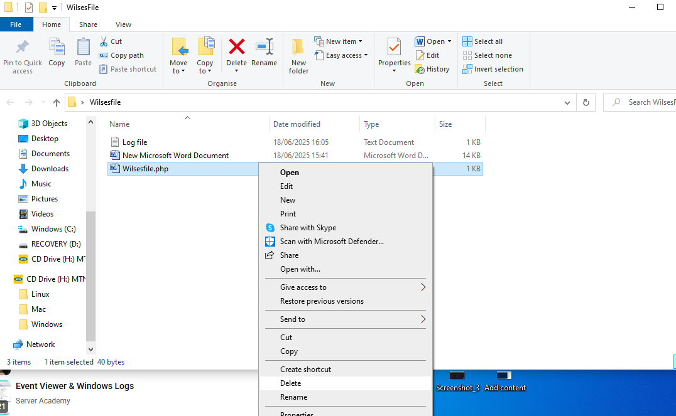
    - Create a log file detailing the actions performed.
To initialize the log file use the command line on the screenshot.
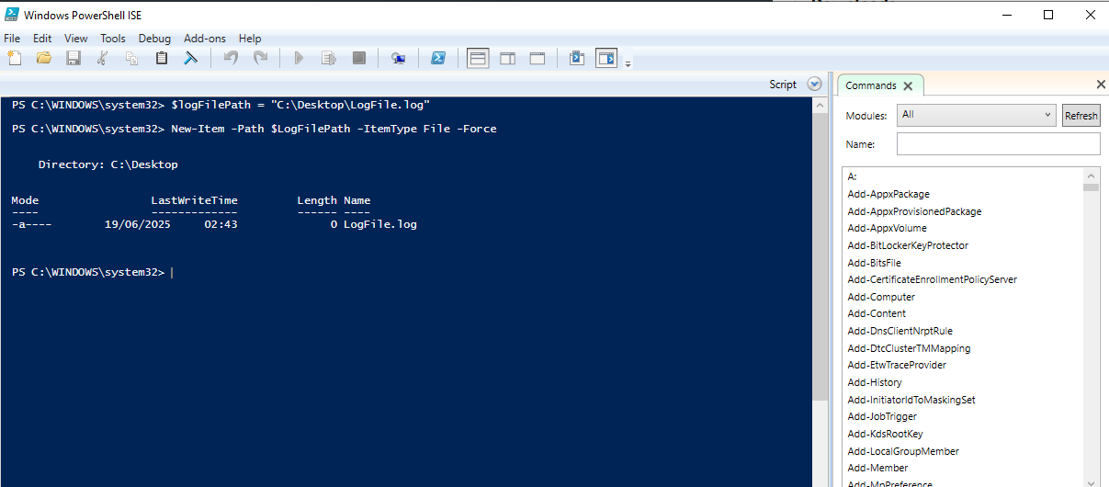
Write to the log file
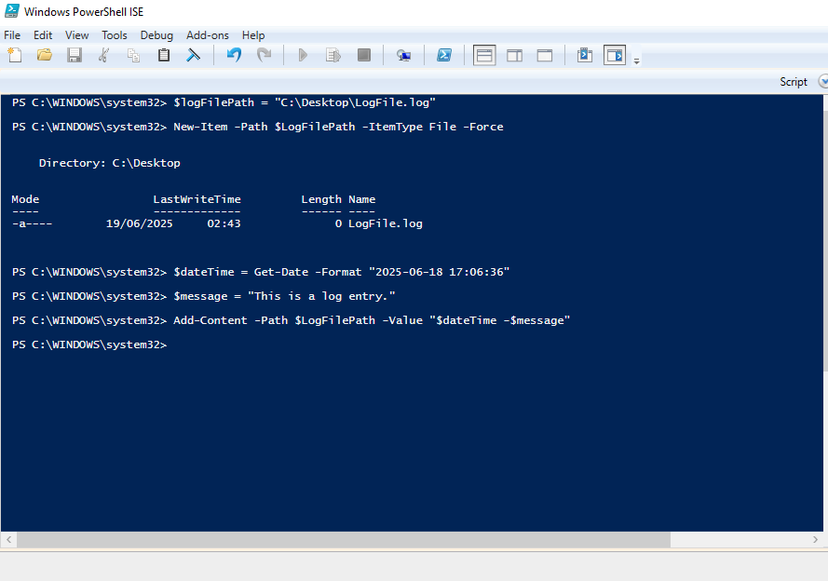
- Monitor System Logs
From the system log, some task category such as user account management read audit success while system integrity read audit failure.
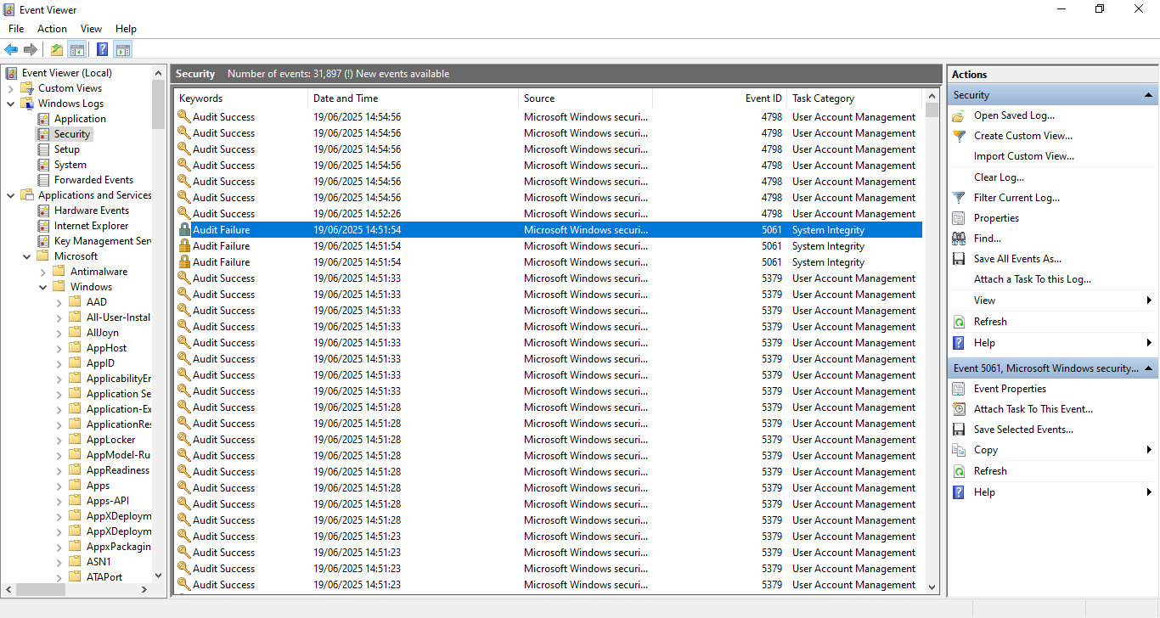
From my findings, the reason why it failed was because the logon attempt was not successful.
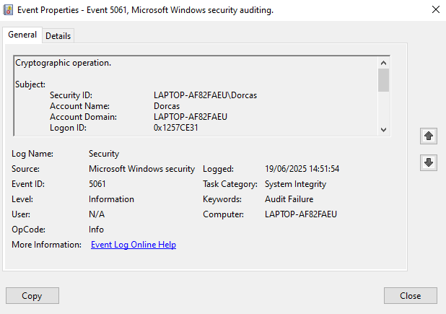
- Analyze Logs
    - File creation

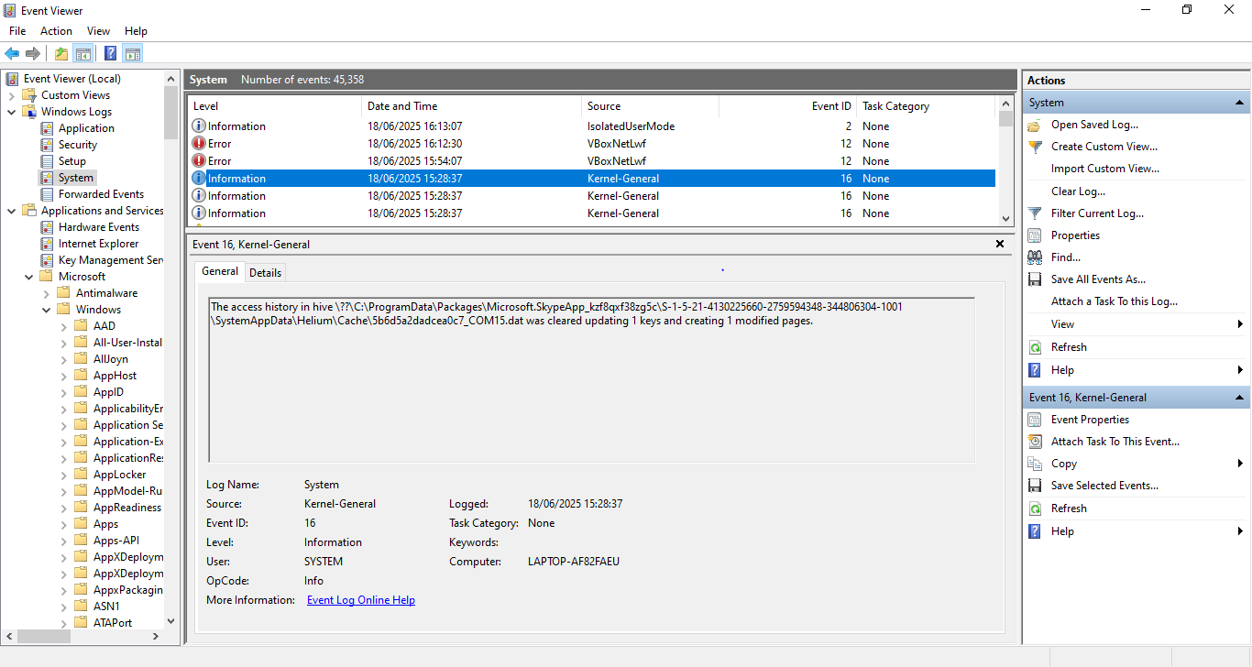
    - File modification
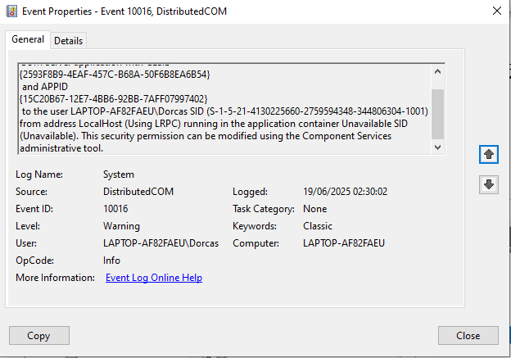
The system date/time was changed from 2025-06-17T21:01:10 to 2025-06-18T13:12:32 keywords says time not audit success.

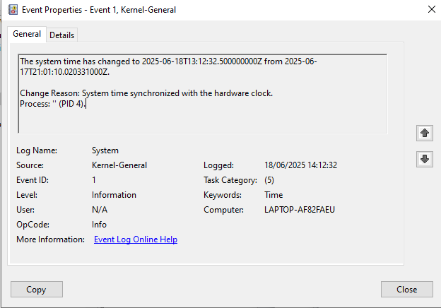
User account was run as an administrator and the key words are audit success.
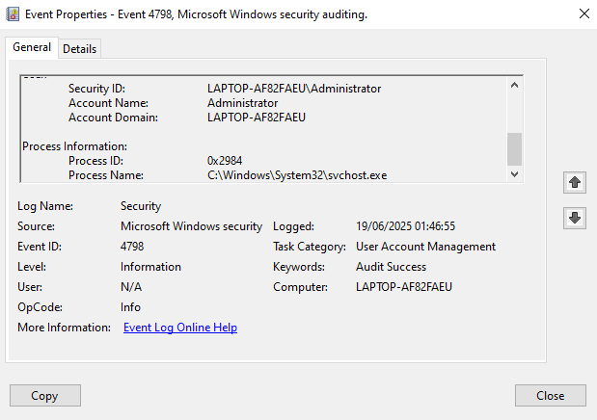
It is obvious that the probability of threat actors penetrating into the system is high because this file can be modified and the information could be used to conduct malicious act.
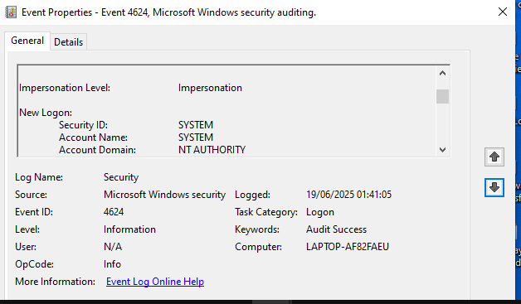
Error message pop up when Wilsesfile.php file was attempted to be modified using PowerShell.

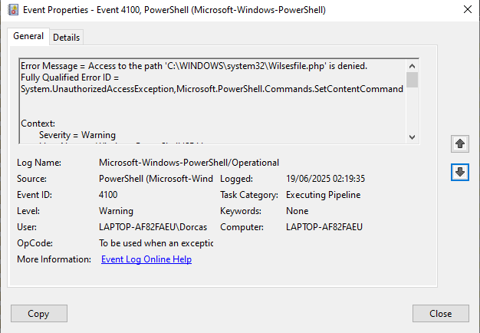
    - File deletion
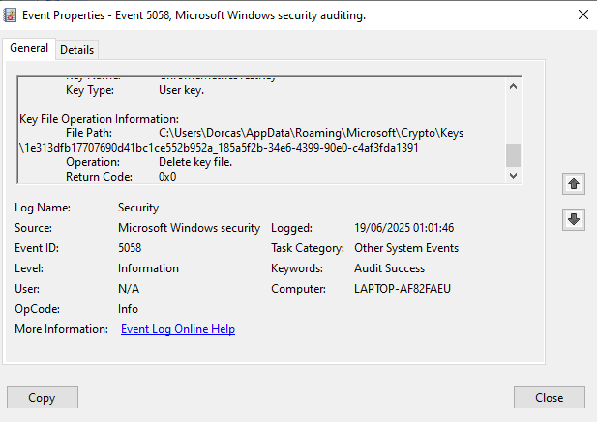
- Use MITRE ATT&CK Framework:
    - Defense Evasion (T1070): Clearing or tampering with logs.
This tactics is used to avoid detection, thereby files are deleted or modified therefore the integrity of the file is not intact.
    - Impersonation ID: T1656
From the above screenshot, we could see that impersonation was discovered on the system log by the event viewer. This could be achieved through phishing email or internal spear phishing by posing as CEO, colleague or third-party vendor to gather sensitive information such as credit card information, target information this could be organization information for a malicious activity.
    - File and Directory Discovery (T1083):
To locate critical files for tampering, dir, ls and tree command was used to locate crucial files using PowerShell administrative command.
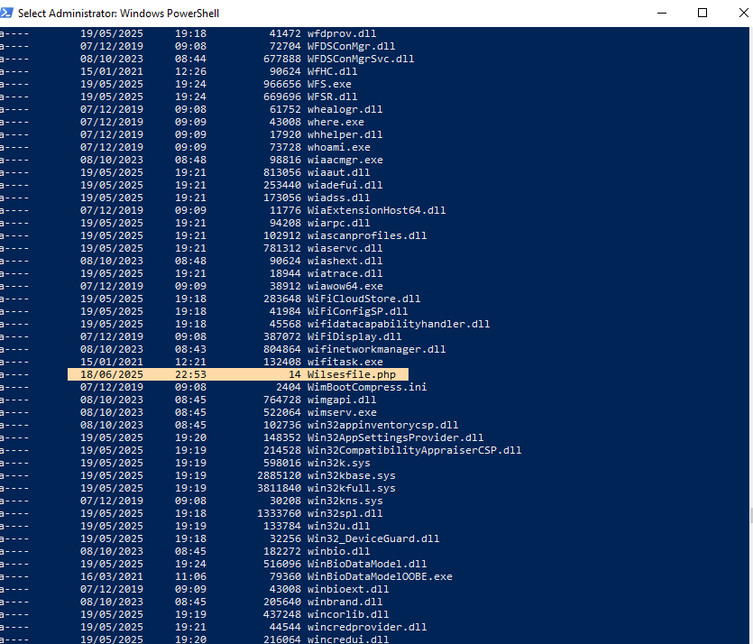
    - Data Destruction (T1485): Deleting files to cover tracks.
The file has been deleted with rm and del command prom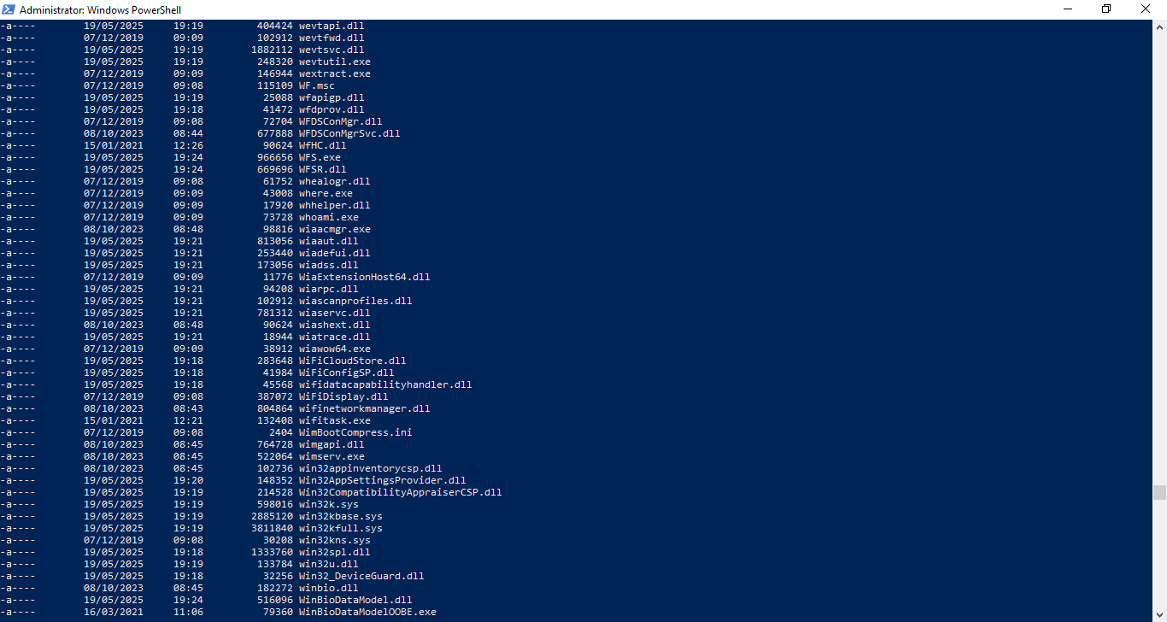
MITRE ATT&CK TECHNIQUES
Technique | Defense Evasion (T1070)  File deletion T1070.004 | Impersonation (T1656) | File and Directory Discovery (T1083) | Data Destruction (T1485)
Impact |  |  |  | Availability
Tactic | Defense Evasion | Defense Evasion | Discovery | Impact
Observed | Yes | Yes | Yes | Yes

5 Mitigation
Defense Evasion (T1070)
Continue to monitor the environment to ensure that file integrity is not altered, ensure all the security patches are up to date, regularly review and remove unnecessary accounts, applications and services to reduce attack surface. Reinforce strong access control and authentication measures.
Impersonation (T1656)
Threat intelligence program should be implemented as this helps both users and defenders to be aware of their schemes that were used and defend against common lures. Users should be trained on how to countermeasure impersonation tricks.
File and Directory Discovery (T1083)
Implement restrictions to sensitive files and directories. Secure coding should be utilized to prevent traversal vulnerabilities in the directory and use honeytokens for detection of unauthorized attempt access. Ensure to secure remote access to files and directories.
Data Destruction (T1485):
Incorporate data backup on all the data, use multi-factor authentication to protect data from destruction as cybercriminal cannot tamper with file and user account management should be implemented as this will limit permissions granted to users.
ii. Suggested Actions
Defense Evasion (T1070) - Use endpoint detection and response (EDR) as this tool will detect and respond to malicious activity. Develop and implement incident response plan to ensure the team are ready for any security incident that might occur.
Impersonation (T1656) – Use Behavioral analysis tools to monitor and analyze users unusual activity such as accessing uncommon files, atypical login times as this will signal impersonation attack in progress to the defenders team and they will take it up from there.
File and Directory Discovery (T1083) - Use File Integrity Monitoring (FIM) to detect unauthorized changes to file and directories. Use IDS to identify suspicious activity and monitor network traffic and SIEM tools should be use to identify their patterns and collect real time security events log.
Data Destruction (T1485) – Use shred machine to destroy paper documents, use industry standards such as NIST 800-88 and ISO 27001 for data destruction.
6. Conclusion
To sum up, the mitigation and actions guide suggested should be implemented to file and directories, data and systems to ensure cyber-actor does not have access to these files and systems.

